**Resolving Merge Conflicts for Test-Deploy-Branch**

1. Take the Latest from your feature Branch (i.e. git fetch & git pull)
2. After that checkout to origin-test-deploy-branch and take latest for test-deploy-branch as shown below

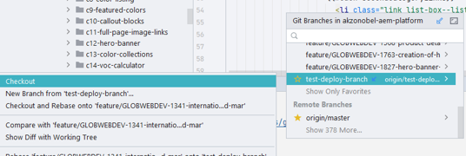

1. Now you can try to merge your test-deploy-branch with your feature branch as shown below

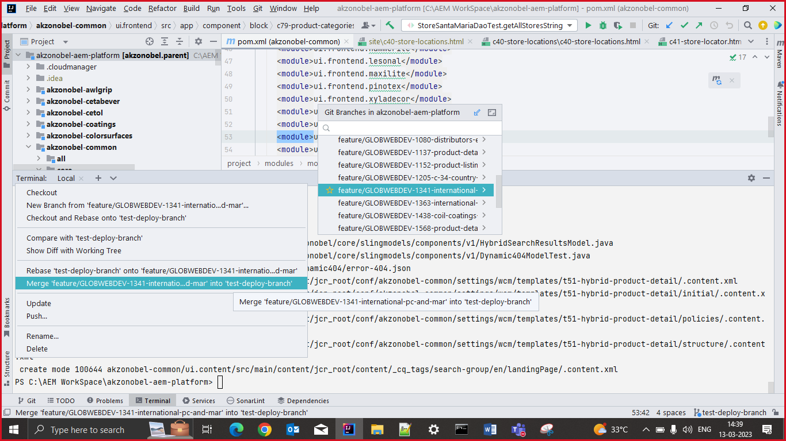

After Merging if there are any merge conflicts its shows at your right most corner as shown below

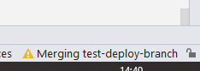

While Merging the below dialog box appears

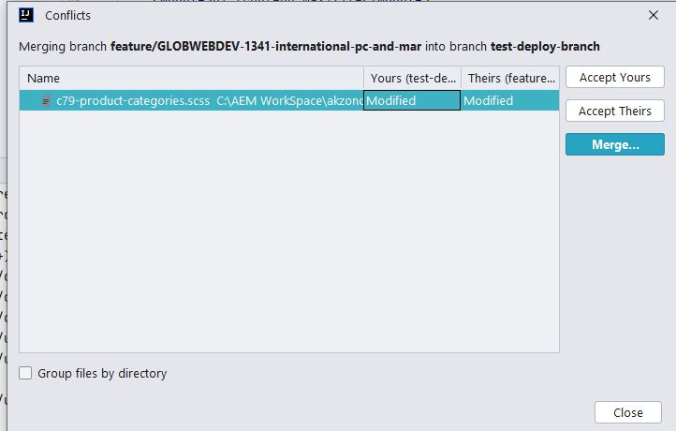

Click on merge and check your changes what needs to be in your result, you can change accordingly once conflicts resolved you can click apply button

1. \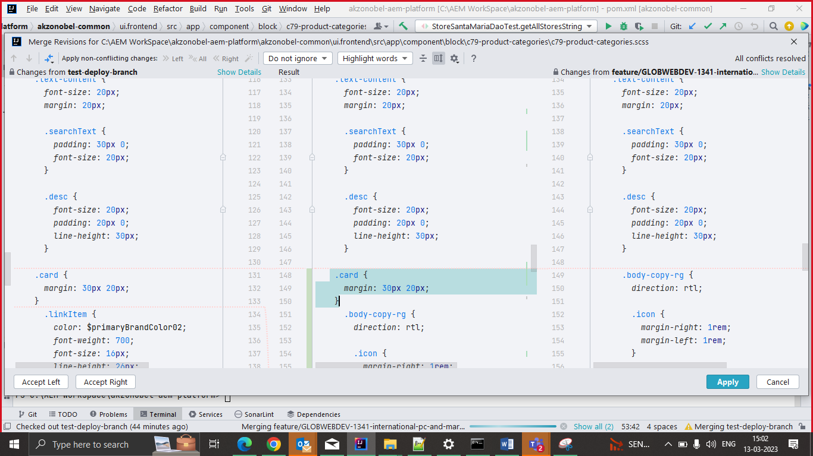
2. Note: You need to push yours changes to test-deploy before other person do